MINI PROJECT REPORT
EQUITY PORTFOLIO TRACKER
Abstract:
The Equity Portfolio Tracker is a simple software application developed to help users manage and visualize their stock investments. The system allows users to input stock names and their respective values, and it dynamically generates a graphical representation of the portfolio using a pie chart. Developed using Scilab, this project demonstrates the application of programming concepts in financial analysis. The tool provides a clear overview of asset allocation, enabling better decision-making for investors.
Introduction:
In today’s financial environment, managing investments efficiently is crucial. Investors often deal with multiple stocks, making it difficult to track their portfolio manually. A portfolio tracker simplifies this process by organizing data and presenting it visually.
This project focuses on building a basic equity portfolio tracker that enables users to input stock data and instantly view their investment distribution. The system uses graphical visualization techniques to enhance user understanding of portfolio composition.
Aim:
To develop a user-friendly application that tracks stock investments and visually represents portfolio allocation using graphical tools.
Objectives:
- To design a simple graphical user interface (GUI)
- To store and manage stock data dynamically
- To implement real-time visualization of portfolio distribution
- To ensure scalability for multiple stock entries
- To apply programming concepts to financial analysis
Software Used:
The project is implemented using:
- Scilab
An open-source platform used for numerical computation, GUI creation, and data visualization. It provides built-in functions such as figure, uicontrol, and pie for developing interactive applications.
Methodology:
- System Design: The system is designed with two main components:
- User Input Section – for entering stock name and value
- Visualization Section – for displaying the portfolio allocation
- Data Handling: Two global arrays are used:
- p_names → stores stock names
- p_values → stores corresponding investment values
These arrays dynamically expand as new entries are added.
- Working Principle:
- The user inputs stock details
- The system validates the input
- Valid data is stored in arrays
- The chart is updated dynamically
Algorithm:
Step 1: Start the program
Step 2: Initialize empty arrays for storing stock data
Step 3: Create the graphical user interface
Step 4: Accept user input (stock name and value)
Step 5: Convert input value into numeric format
Step 6: Validate the input
- If valid → proceed
- If invalid → ignore
Step 7: Store the data in arrays
Step 8: Clear previous chart
Step 9: Generate updated pie chart
Step 10: Reset input fields
Step 11: Repeat until program ends

Implementation (Code):
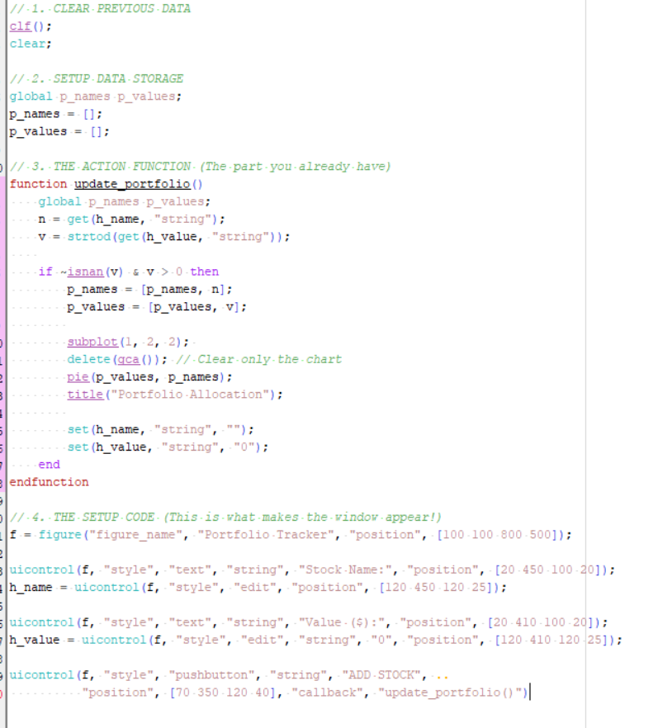
Output:
The output of the system is a graphical window displaying:
- Input fields for stock details
- A button to add stock entries
- A dynamically updating pie chart
The pie chart visually represents:
- Each stock as a slice
- Proportional investment distribution
This helps users quickly analyze their portfolio allocation.
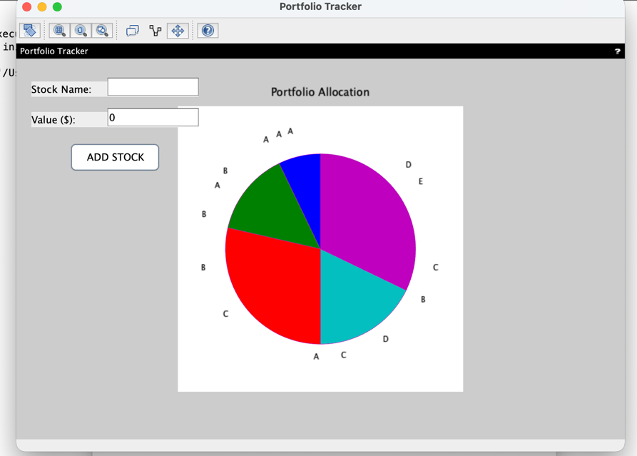
Scalability:
The system is scalable due to:
- Dynamic array expansion
- Real-time updates
- Flexible GUI structure
Possible Enhancements
- Data saving and loading functionality
- Editing and deleting stock entries
- Integration with live stock market APIs
- Performance and return analysis
Conclusion:
The Equity Portfolio Tracker is a simple yet effective application for managing stock investments. It successfully demonstrates the use of graphical interfaces and data visualization in financial applications. Developed using Scilab, the system provides real-time insights into portfolio distribution.
Although basic in functionality, the project can be further enhanced to include advanced features such as analytics and real-time data integration. This project serves as a strong foundation for developing more complex financial management tools.
SUBMITTED BY:
APOORVA VISHWAKARMA (202410101150216)

